(Approx. 1,807 words)

The AntiSpyware Revolution Starts Here
By Lou Torraca, President, The TUG, Hawaii
http://www.the-tug.org/
Af06hi(at)gmail.com

Obtained from APCUG with the author's permission for publication by APCUG member groups.

CounterSpy V2 was completely rebuilt with a revolutionary new design. More powerful and effective than ever, CounterSpy's award-winning spyware detection and removal is now merged with our all-new VIPRE™ antimalware technology to create the industry's first hybrid antispyware engine.

- Heavy-duty antispyware protection treads lightly on system resources.
- Kernel-level active protection.
- Hybrid design combines antimalware technology with our award-winning spyware detection and removal.
- Deep-rooted malware is exterminated at boot time, before Windows loads.
- Incremental definition updates greatly reduce update downloading time.
- Vista compatible: Integrates seamlessly with the Vista Windows Security Center.

Sounds pretty good doesn't it? The description above from Sunbelt Software caught my eye and I decided to check it out. What follows is a list of the features, system requirements, some suggestions before your install and a blow by blow that recounts my download, install and use of CS. As always, I recommend you backup your files and/or set a restore point before you begin.

Features
CounterSpy contains the following key features:

- System Scan - The scanning engine checks your entire computer by using in-depth scans ofyour computer's hard drives, memory, process, registry and cookies. It uses a continually updated database of thousands of known spyware signatures to provide you with ongoing and accurate protection. You can scan for spyware manually or schedule times for CounterSpy to scan your computer.
- Active Protection - Active Protection guards your computer's privacy and personal information from hidden spyware threats before they can attack. Active Protection acts as a series of security checkpoints, comparing any unknown activity with the most up-to-date database of spyware threats at Sunbelt's Research Center - stopping new spyware in its tracks.
- System Tools - My PC Explorers let you explore and manage key elements of your system that are normally hidden and difficult to change. My PC Checkup helps secure your computer by updating your computer settings to recommended security levels. The History Cleaner is a privacy tool that removes all Internet History usage logs and 75 different activities. The Secure File Eraser is a powerful deletion tool that completely erases any files you want removed from your computer.
- First Scan - Before your computer completely boots up, CounterSpy deletes tough to remove or locked files and catches spyware before it has a chance to run on your computer.
- VIPRE - VIPRE is an antivirus technology that enables CounterSpy to further analyze each suspect item, using heuristic and detection definition files.

System Requirements
Make sure your computer meets one the following system requirements in order to run CounterSpy effectively:

Operating System Requirements:
Windows 2000 Professional and Windows XP Professional/Home SP2, Vista

Minimum

Intel Pentium II processor (or compatible) at 133 MHz or higher with at least 128 MB of RAM
32 MB of available hard disk space
Internet Explorer 5.0 or higher Recommended
Intel Pentium III processor (or compatible) at 1Ghz or higher with 256 MB of RAM.
(I wouldn't recommend the minimum and as for the recommended, I'd go for at least 512 MB of RAM.)

Before Installing CS make sure to uninstall any other anti-spyware programs and restart your computer. Also, close all other Windows programs, including programs displayed in the Windows system tray. (I didn't uninstall my other antispyware as I don't have them scheduled to run, I do it manually.) One note-CS turns off Windows Defender, but you can turn it back on as I did, and didn't have any problem running it.

Installing CS
I downloaded CS to my desktop, then did a scan with my AVG and clicked on it to open the installation wizard. After CS is installed and you have restarted your computer, double-click the icon on your desktop or click Start; then, select All Programs>Sunbelt Software>CounterSpy>CounterSpy. The Getting Started setup wizard opens. The wizard guides you through the initial steps needed to configure CS.

After you complete the Wizard and open CounterSpy, the main page is displayed.

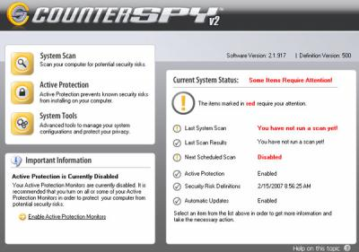

It provides general summary information like the last time you ran a scan, when the next scan is scheduled to run, important information, etc. Notice that it also contains buttons for you to access the three main features that are covered next-System Scan, Active Protection, and System Tools. You can also update your security risk definitions by clicking the link in the Important Information box. The updated version is displayed above the current status box along with the software version number. The key thing to note on this page is the red text next to Current System Status: Some Items Require Attention. This text alerts you to the status of key items in the list below; for example, if you have not run a can, or if Active Protection is disabled.

System Scan
Click the System Scan button on the main page to open the System Scan page.

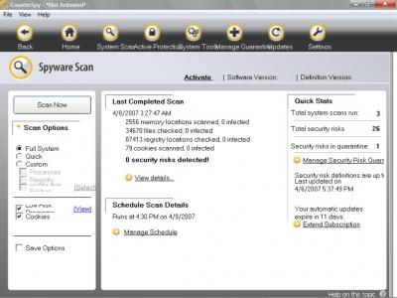

Scanning is CounterSpy's main function. The System Scan page allows you to set scan options, perform scans, access the scanning schedule page, access the Manage Quarantine page, view scan details, and extend your subscription for updating security risk definitions. Take a note of the Scan Options listed on the left side of the System Scan page. You can select from three system scan options: Full System, Quick, and Custom. For the purposes of this review, you should use the default setting, a Full System scan, to scan your computer's processes, registry, drives, and folders.

To scan your computer

Click Spyware Scan on the main page; then, set the scan options on the left side of the page. I recommend you select Full System scan.
Click Scan Now. CounterSpy starts scanning your computer. After the scan is complete, the CounterSpy Spyware Scan Results summary window opens.
Review the summarized information; then, click View Results. You go to the Spyware Scan results page.

Scan Results
After your computer is scanned, a scan results dialog box is displayed. Click OK, to open the Scan Results page. Review the items listed on the page; then, take actions against spyware threats. The dropdown lists under recommended actions provide you with several options. You have four options to choose from when managing the scan results: Ignore, Quarantine, Remove, and Always Ignore. To set a single action for all spyware threats, click the link: Set a single action for all spyware threats; then select the action from the Recommended Action drop-list.

Scheduling Scans
The Manage Schedule link on the System Scan page allows you to set the scanning schedule. The Spyware Scan page offers four main selections: Add a new schedule, view/edit a current schedule, enable/disable a current schedule, or delete a schedule.

When you click the Add New or View/Edit buttons, the schedule wizard opens. Use this wizard to set the dates and times as well as the scan options for the scheduled scan. The options below the Scheduled spyware scan drop-list change depending on the selection you make. Also, CounterSpy must be closed for the scheduled scan to run.

Working with Active Protection When software is installed, or when a change is made to your computer, an internet setting, or an application setting, Active Protection quickly reacts to analyze the change. CounterSpy decides to allow the change if it is not threatening, block the change if it is known spyware, or ask you to decide.

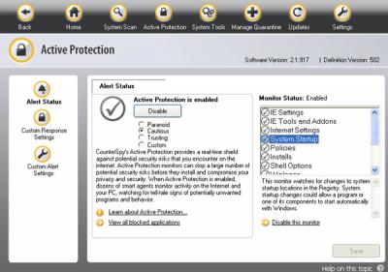

Click the Learn about Active protection monitors... link to open a page with detailed information about Active Protection Monitors. Active Protection helps protect your privacy and identity, as well as prevent unauthorized programs from taking control of your computer. It works much like a series of security checkpoints in your computer. It monitors system changes, application changes, and internet activity, watching for anything that could be potentially hazardous.
When Active Protection prompts you for action, a small Notice alert window is displayed in the bottom right corner of your computer screen that includes information concerning the change. This enables you to make an informed decision regarding the notice. You can quarantine the item, allow the action, or block the action. You also have the option of remembering the action you select and/or sending feedback to ThreatNet, a community that connects hundreds of thousands of CounterSpy endusers together so they can share and identify spyware risks. These popups will probably bother you, as they did me, at first, but I think they should show up less frequently as the programs learns which are ok based on your checking the remembering box.

System Tools
CounterSpy contains four unique system tools to help you maintain a clean, smooth running computer: My PC Explorer, My PC Checkup, History Cleaner, and Secure File Eraser.
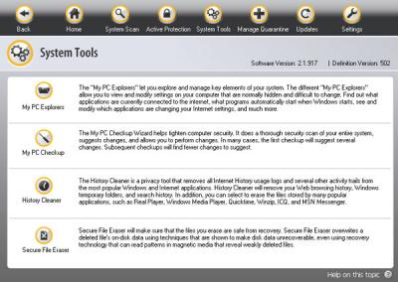

My PC Explorer
My PC Explorers enable you to explore and manage key elements of your system. Use them to view and modify settings on your computer that are normally hidden and difficult to change. My PC Explorers are powerful tools. Use them to find out what applications are currently connected to the internet, what programs automatically start when windows starts, to see and modify which applications are changing your Internet settings, and much more.

My PC Checkup
My PC Checkup helps tighten computer security. It updates your computer settings to recommended security levels. It thoroughly scans your computer for over 1000 different settings, suggests recommended changes, then, allows you to execute the recommended changes.

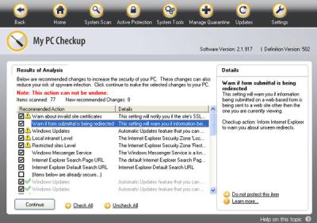

The first time you run My PC Checkup; there could be many recommended changes. Subsequent My PC Checkups will contain mostly suggested changes.
History Cleaner
The History Cleaner is a privacy tool that removes all Internet History usage logs and 75 different activity histories from the most popular windows and Internet applications. History Cleaner enables you to delete your Web browsing and search history, and Windows temporary folders and your search history. You can also erase the history stored by many popular applications, such as Windows Media Player and MSN Messenger.

Secure File Eraser
The Secure File Eraser is a powerful deletion tool that completely destroys files you want to remove from your computer. The Secure File Eraser completely removes all traces of selected documents, images, music, movies, or applications under 10MB in size.
Summary
As you can see, this program does a huge bunch of stuff in addition to just protecting your computer from spyware, malware, etc. The more you use it and review the help program, the more features you will find. To get your fully functional copy of CS, visit www.sunbeltsoftware.com .

That's it for now, until next time, have fun with all those computer and electronic gadgets, but remember to be careful out there on the 'net!
Aloha, Lou

This article has been provided to APCUG by the author solely for publication by APCUG member groups. All other uses require the permission of the author (see e-mail address above).

